New World Gen Audio – WAF Testing

eaas.omnicomgroup.edgekey-staging.net

e176332.dsca.akamaiedge-staging.net. 20 IN A 23.48.168.206
e176332.dsca.akamaiedge-staging.net. 20 IN A 23.48.168.211

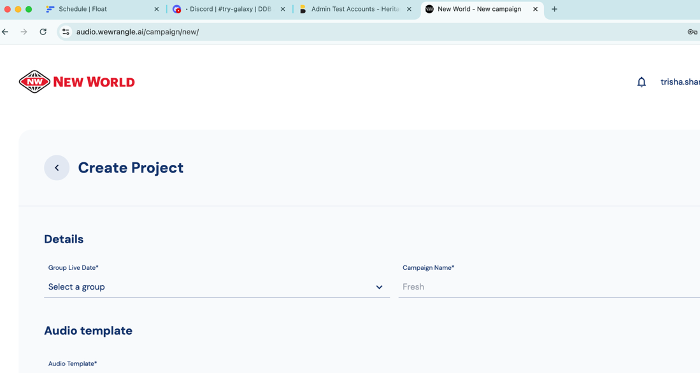

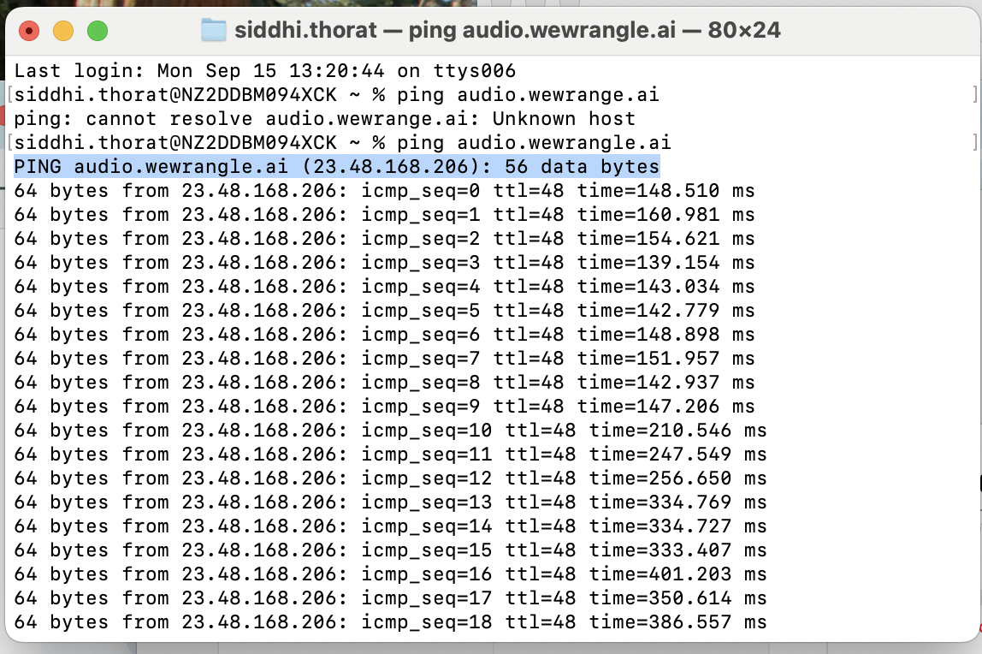
Verified correct ip is being pointed
-------
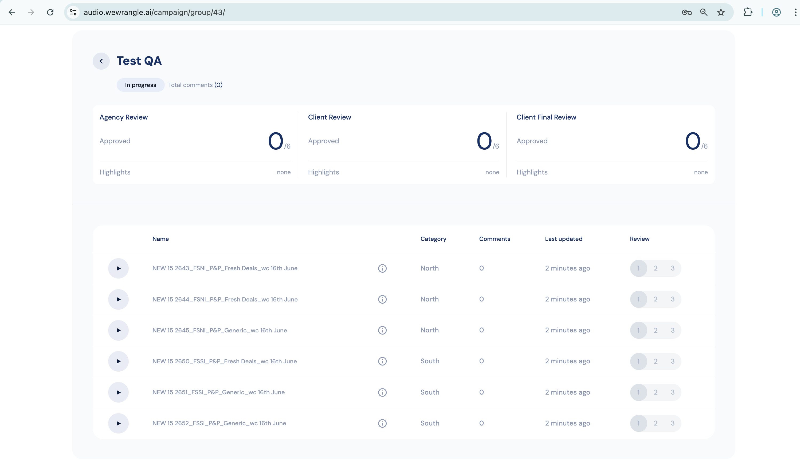
Spots creation after uploading of BGM and Voice over files.
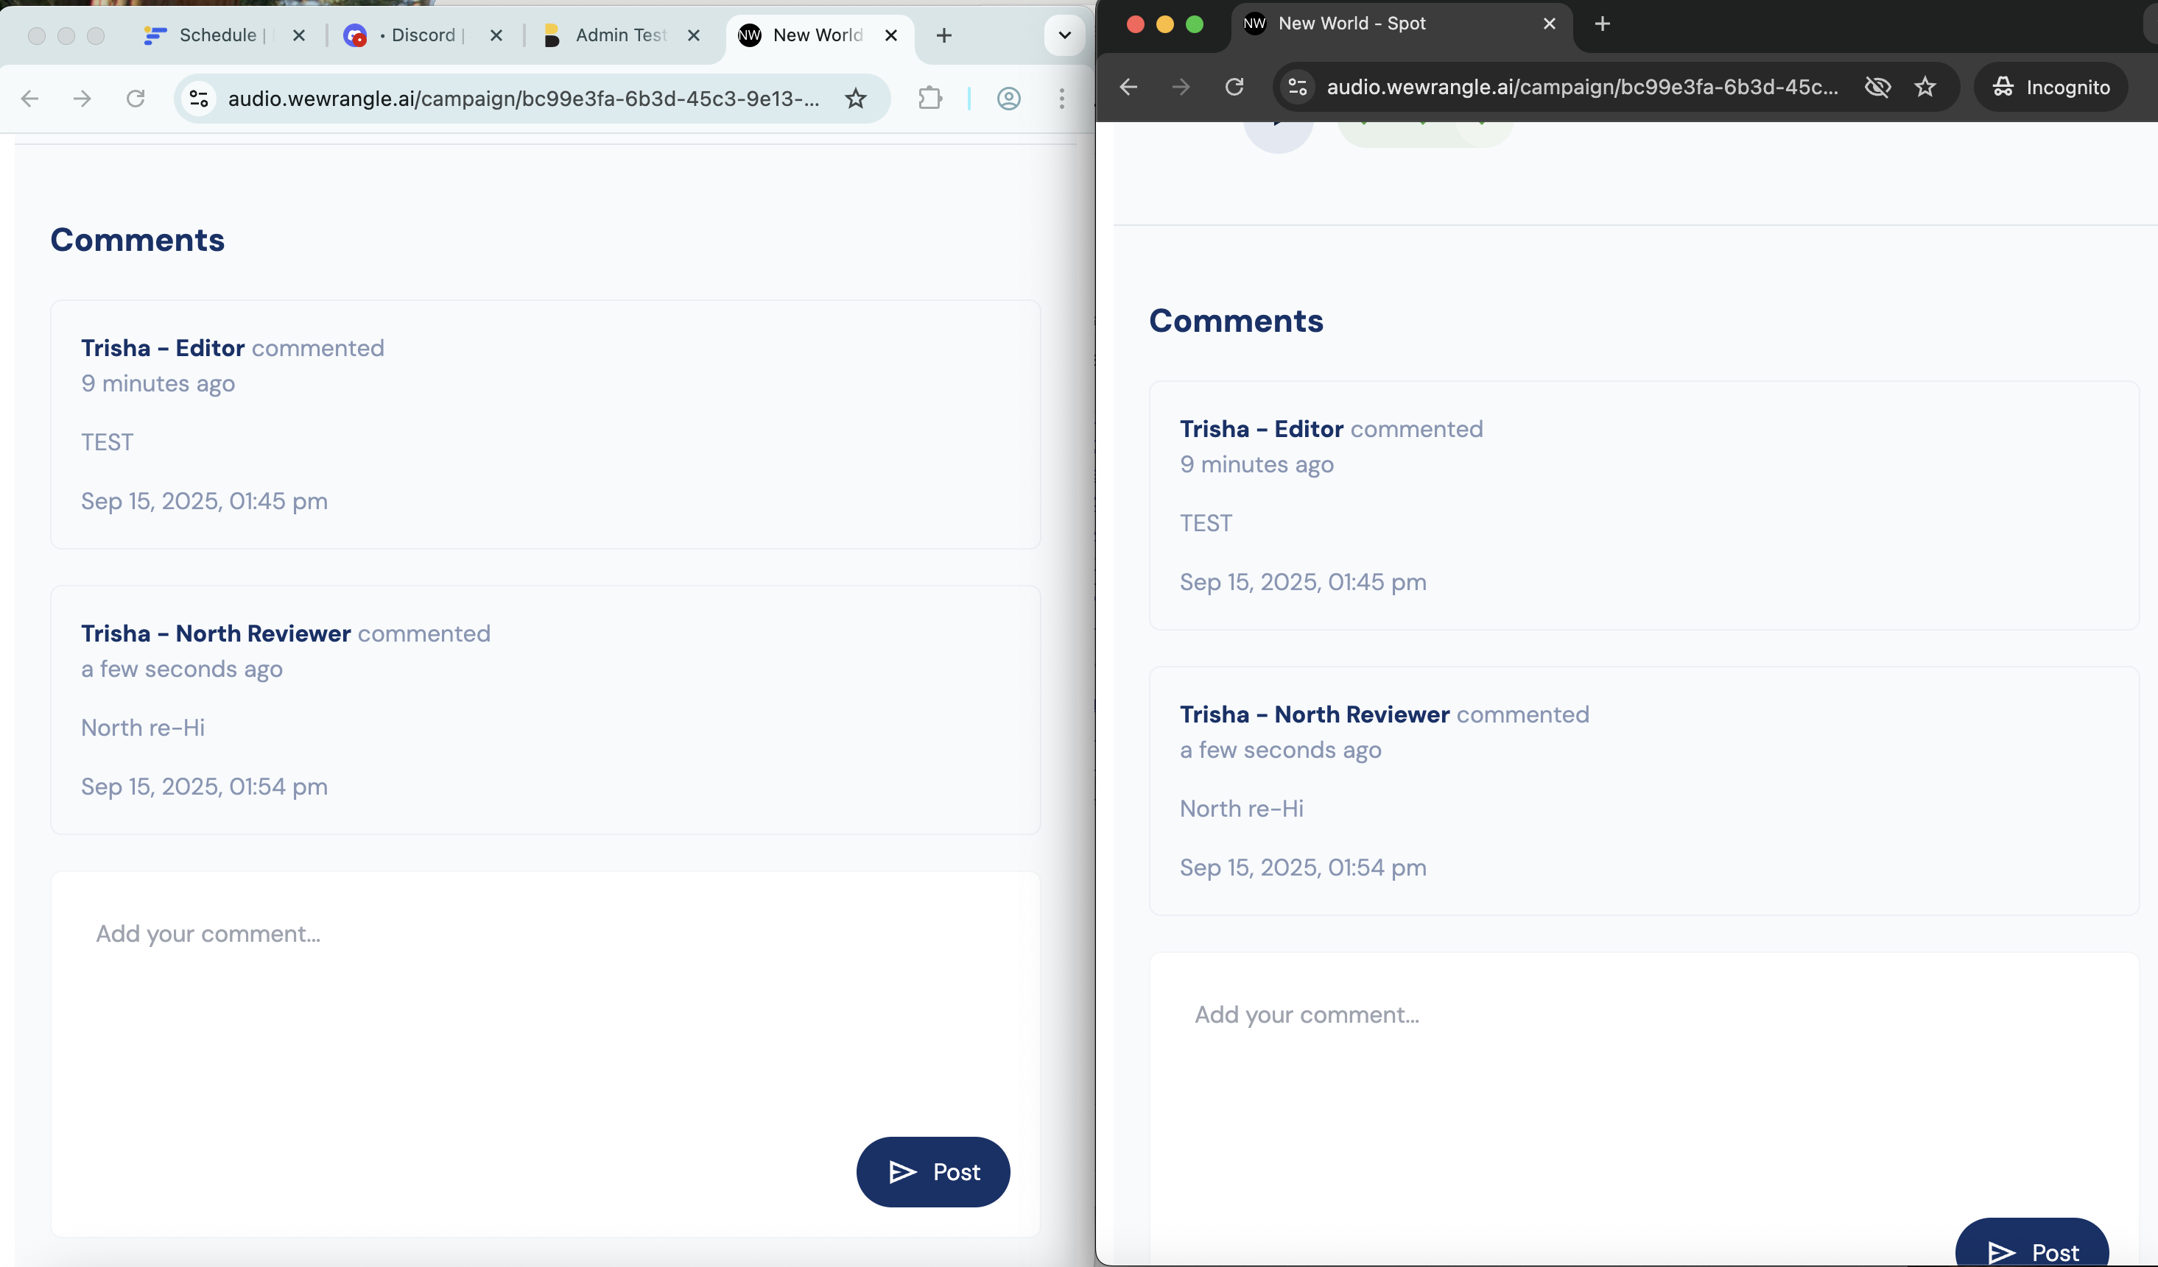
Comments by Editor and Reviewer
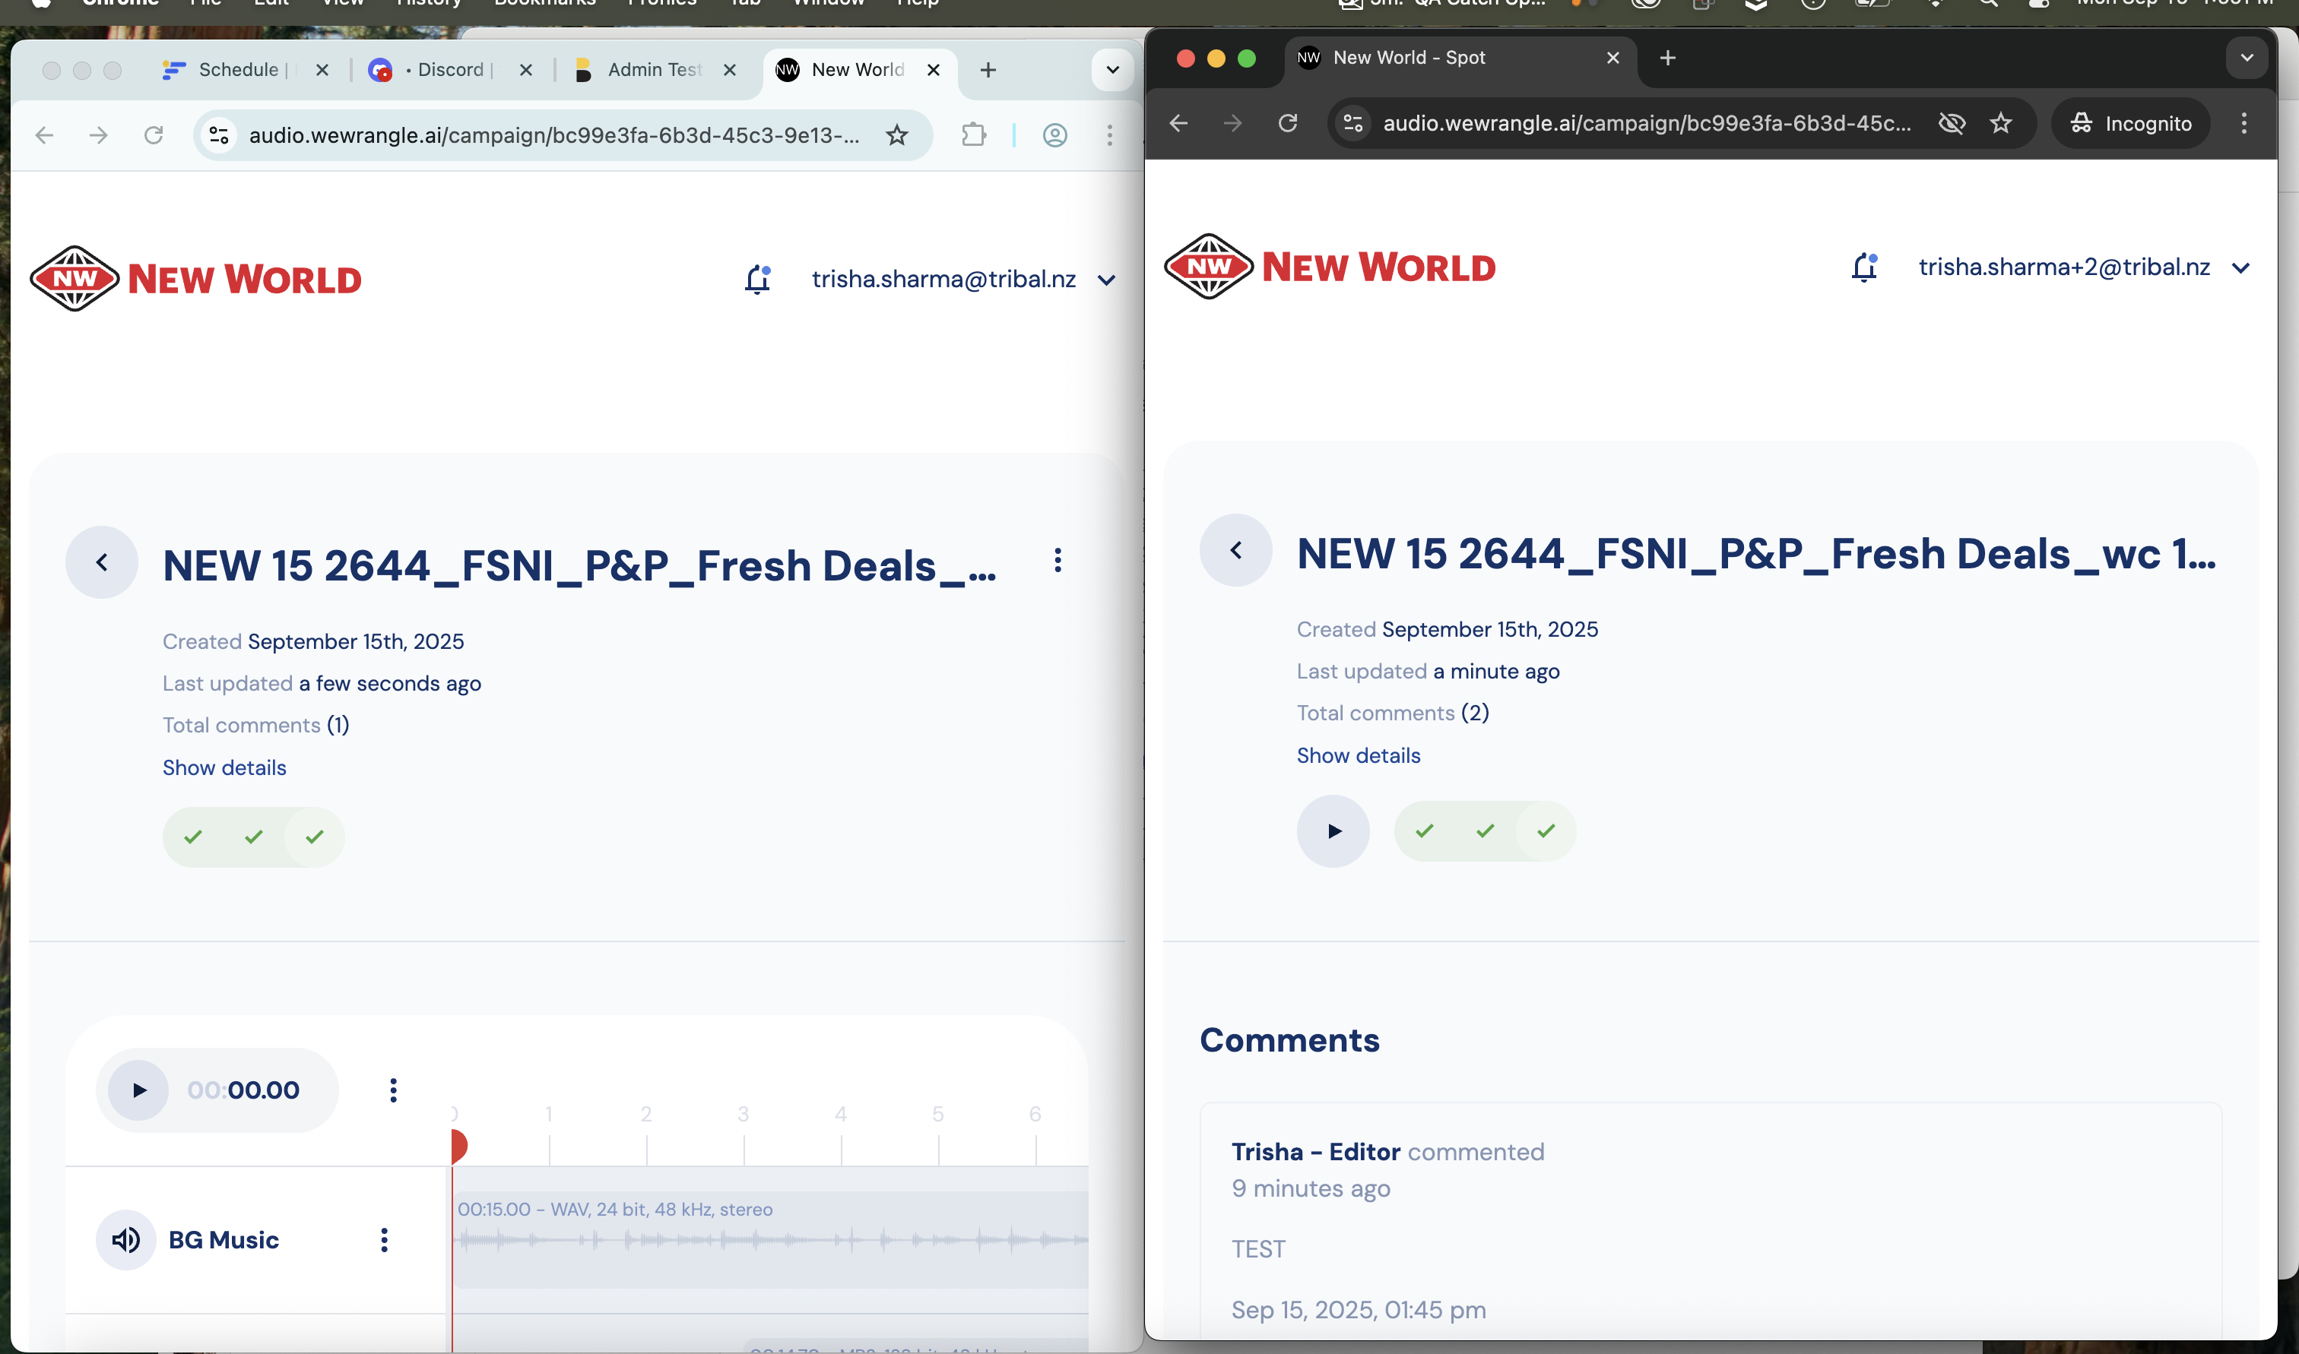
File approvals by Editor and Reviwer
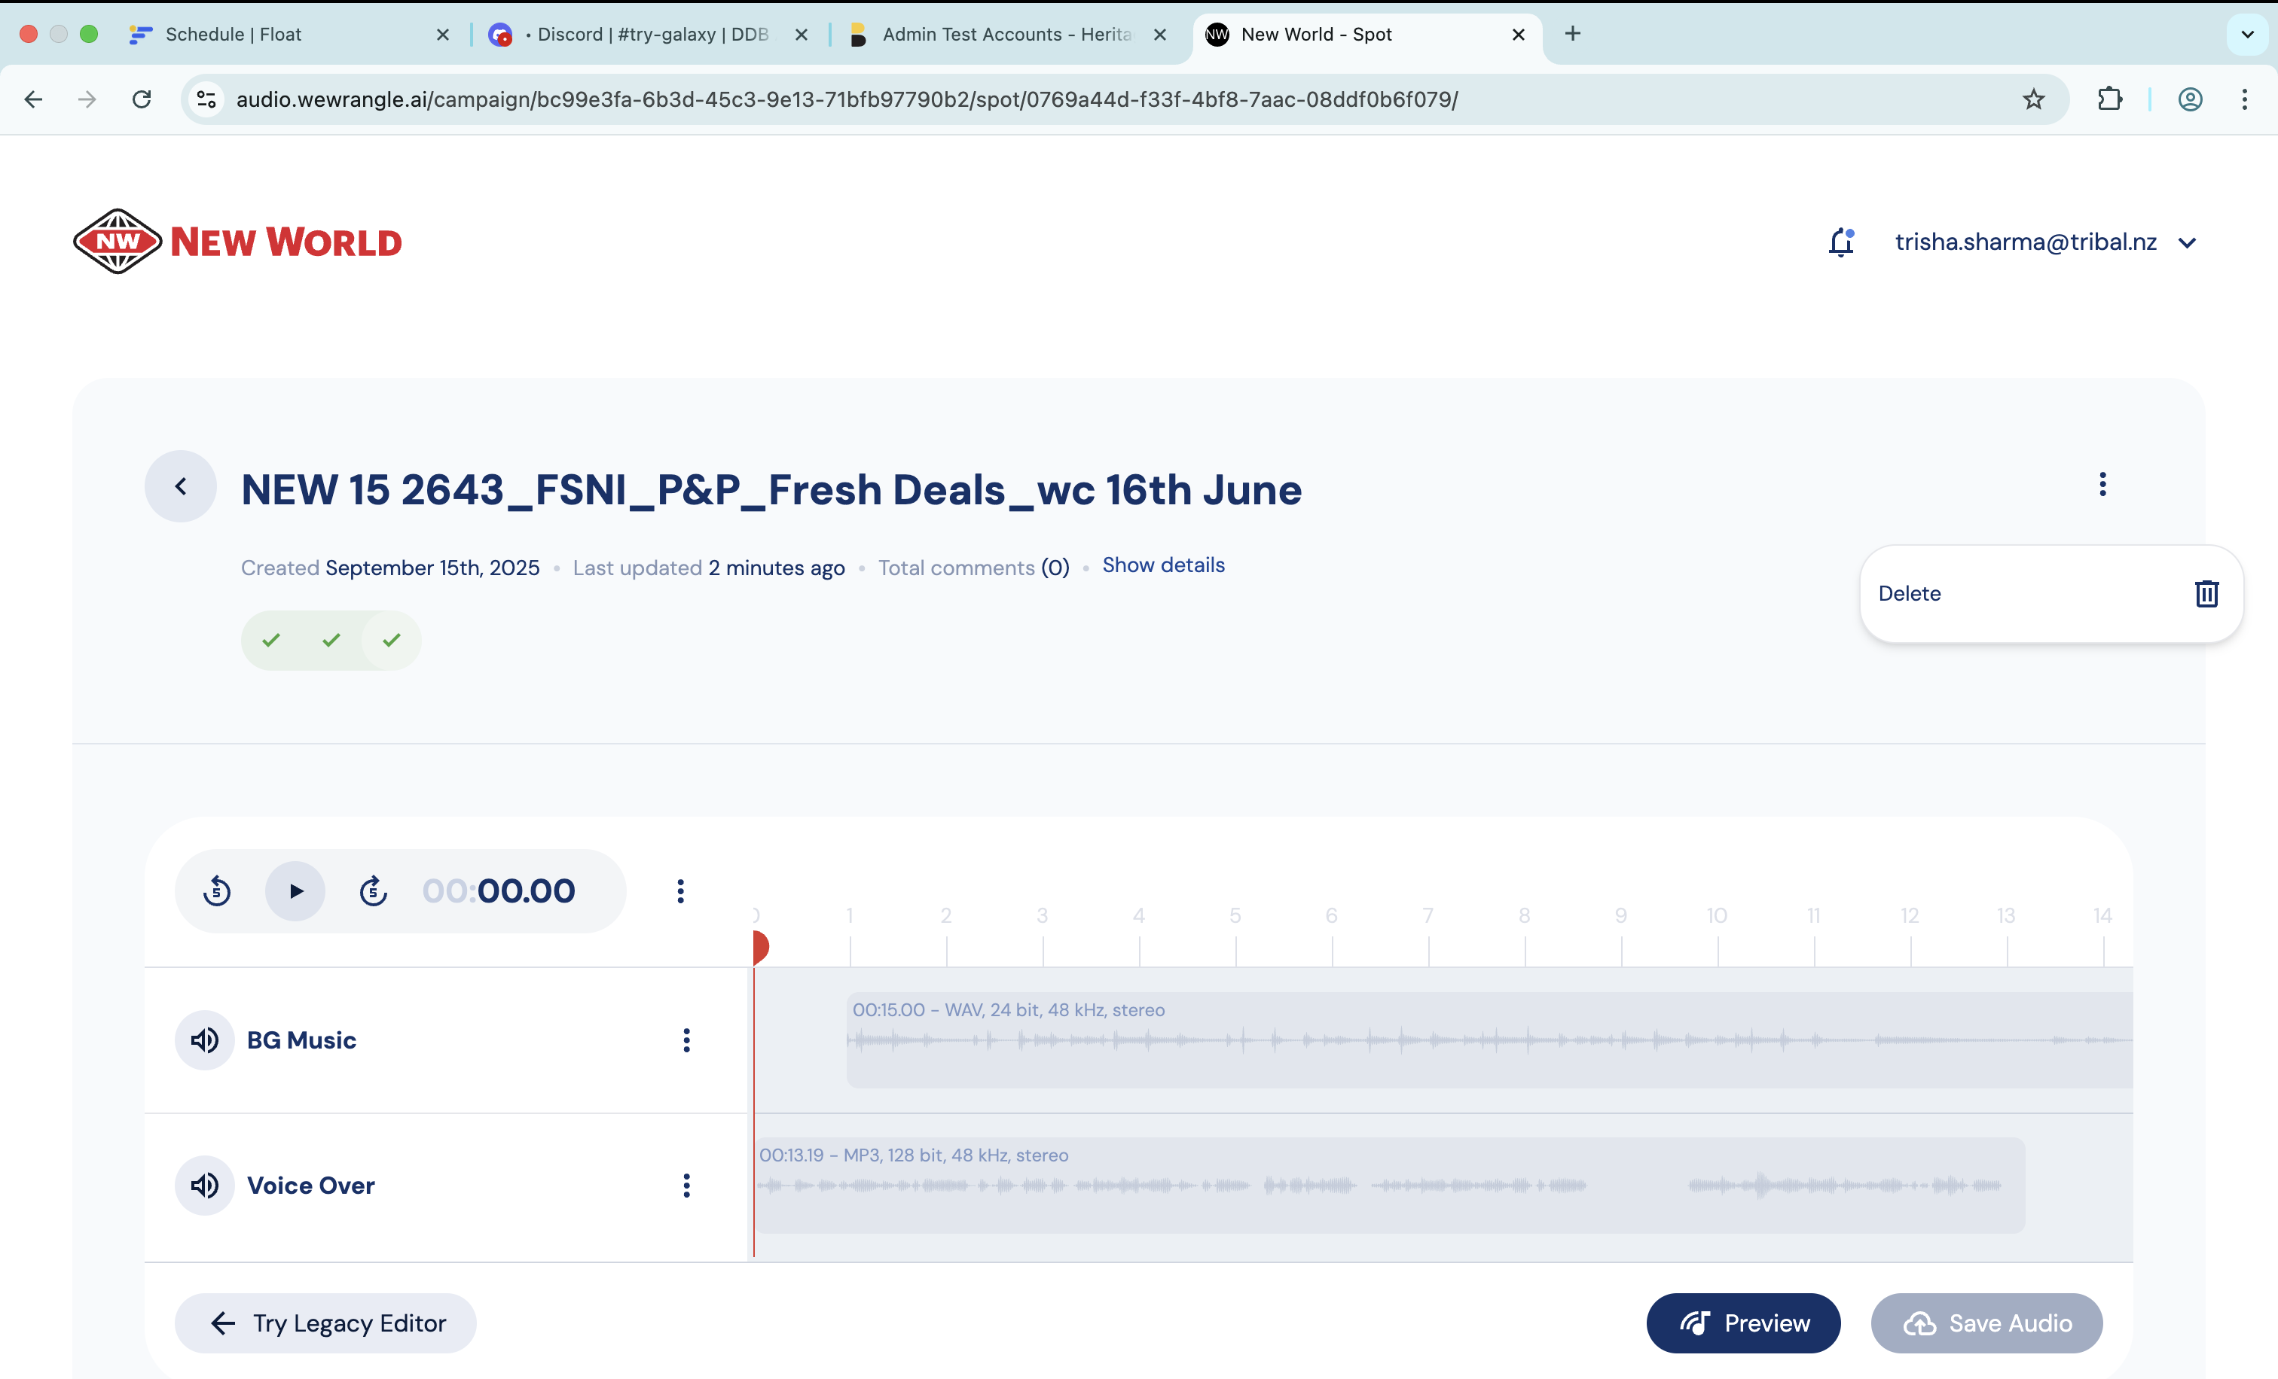
Spot delete
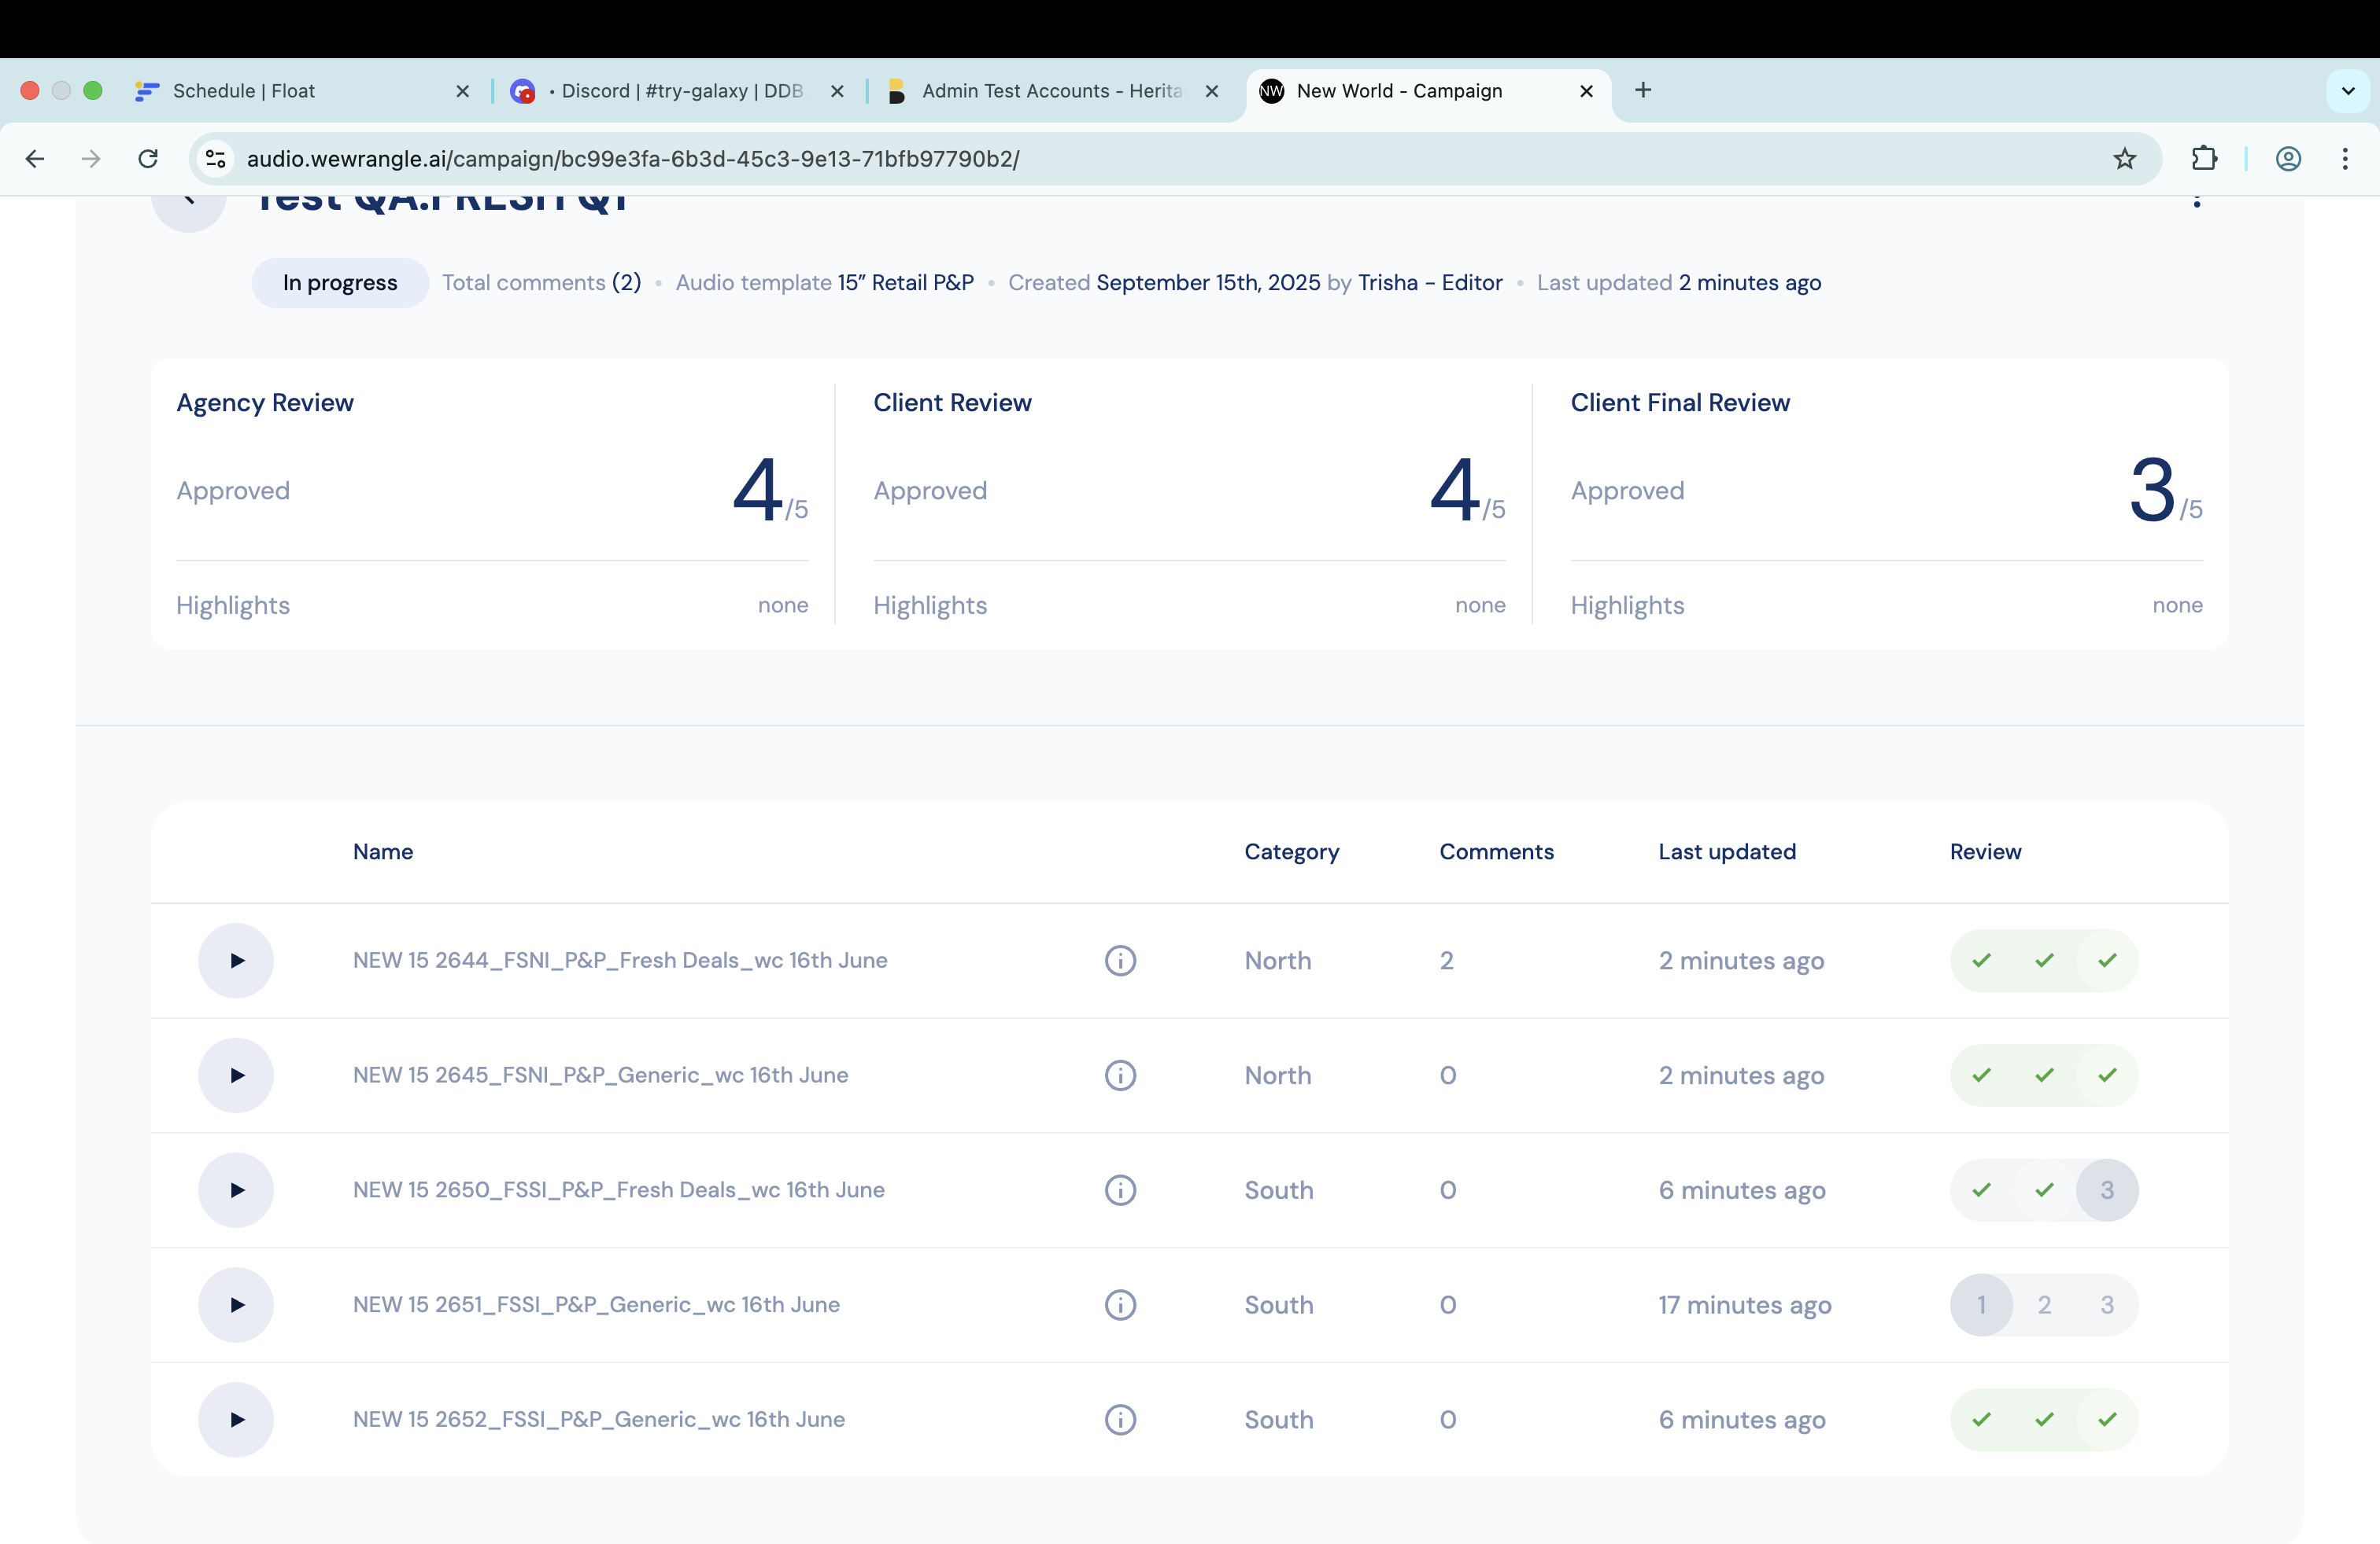
Spot delete.
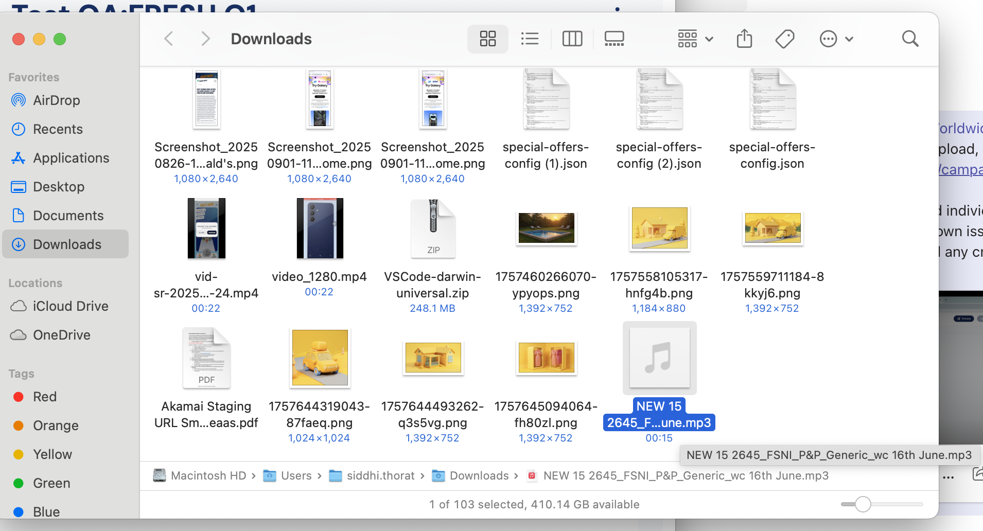
Download spot

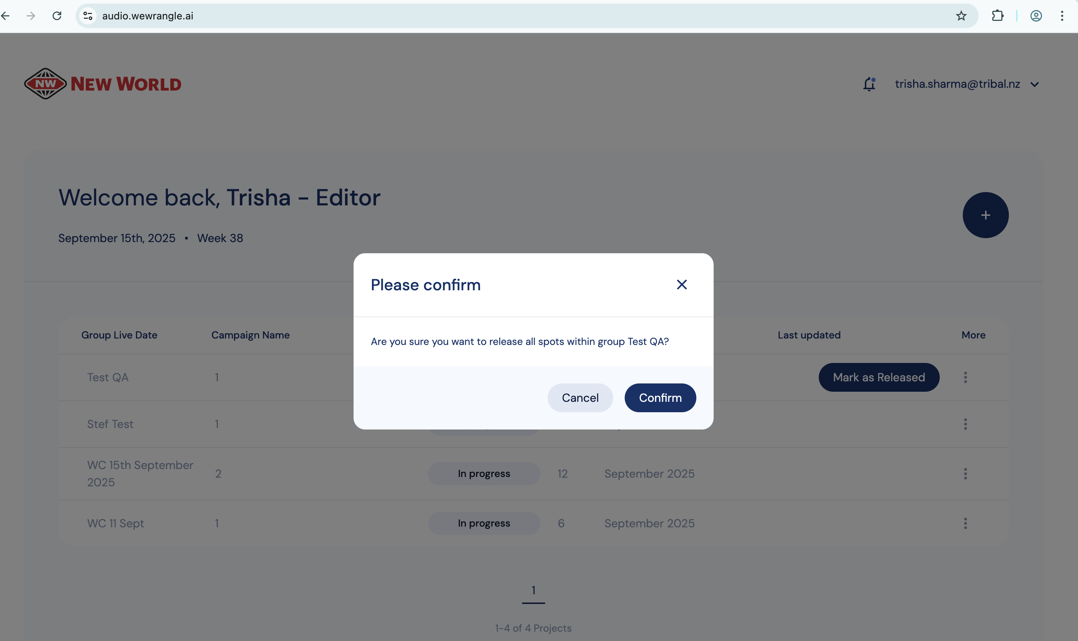
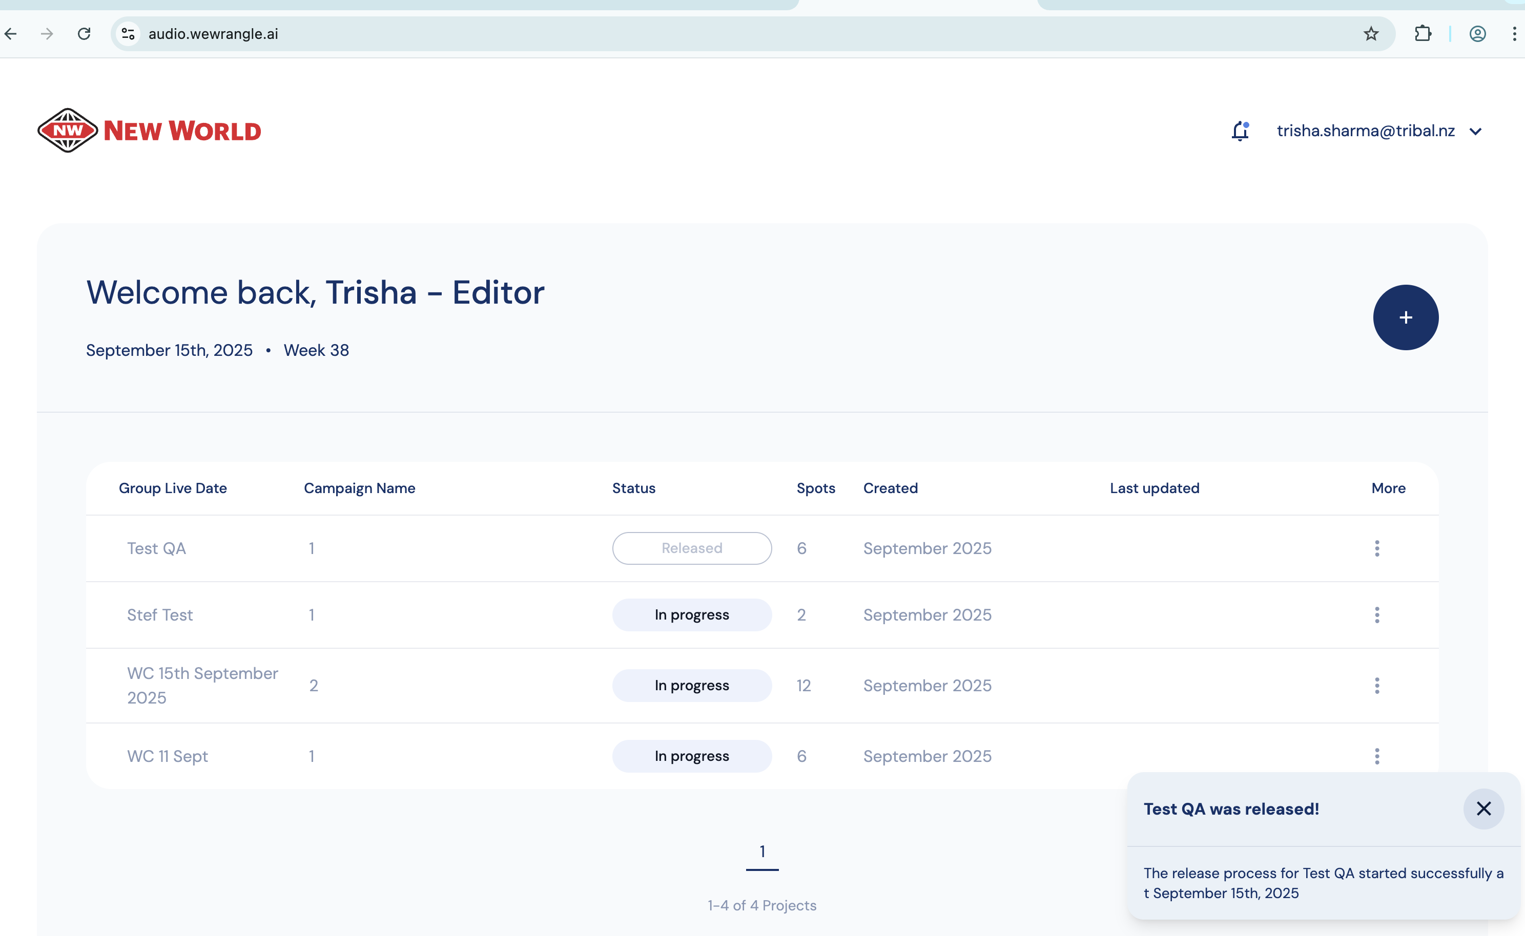
Released campaign

